Document Name |  | Confidentiality Level
XX Project |  | Only for Recipients Reference
Template Code | Version | Document Code
 | 2.0

CMS Project Closure Summary Report

DBMS 12

Copyright © DBMS 12 Co., Ltd.
All Rights Reserved
Revision Record
Date | Revision Version | CR ID /Defect ID | Sec No. | Change Description | Author

Content
1. Project Basic Situation 4
2. Project Acceptance Coverage 5
2.1 Project progress 5
2.2 Development environment 5
2.3 Project Structure 5
2.4 Application 7
2.5 Deliverables 19
3. Project Work Summary 19
3.1 Document work summary 19

1. Project Basic Situation
Project Name: | CMS | Project Category: | Java
Project ID: |  | Technology Used: | JSP,CSS,SERVLET
Development Environment: | myeclipse | Running Platform: | Web brower
Project Start & Finish Time: | Start : 2017.5.29  Finish : 2017.6.20 | Project Working Place: | Windows8.1
Project Manager: | 张瑜
Project Developer: | 杜月锌、韩婉霞
Project Description | With the rapid development of information technology, people gradually realize that the utilization of information management software can make daily work more convenient, fast and efficient. The paper discusses in detail the development and design process of the contract management system. The software adopts JSP development technology, Tomcat as the container, SQL Server 2008 r2 as the database management system, several big function to create, modify, delete contract, contract payment reminder, contract management, contract query time.. Management software meets the contract requirements, can help the company enhance its work efficiency. Software development in line with the general management of the software development process, of great reference value for the development of other similar management software

2. Project Acceptance Coverage

2.1 Project progress
(S.N.) | Stages | Scheduled start/end time | Actual start/end time | List of deliverables | Remarks
1 | Project start | 5.29-5.30 | 5.29-5.30 | Project Start Report | write
2 | Project planning | 6.01-6.03 | 6.06 | Project Planning | Read and fill
3 | Requirement analysis | 6.02-6.04 | 5.30 | Software Requirement Specification | Read and fill
4 | System design | 6.02-6.06 | 5.30 | Each iterative source code | Read and fill
5 | Coding and test | 6.06-6.19 | 6.06-6.19 | Finalized project codes | develop
6 | Acceptance | 6.19-6.20 | 6.19-6.20 | Useer Manual /  Project Closure Report | write

2.2 Development environment
System/Tool/Component | In English (version number) | Remarks
Operating system | Windows 8.1
Development tool | myeclipse

2.3 Project Structure
2.3.1. Project structure design idea

Writing servlets implement each functions and call jsp which use css to show the website on the suppose of tomcat.
系统主界面
错误信息

系统登录界面

系统管理

输入操作员及密码

检查
数据库
密码错误

密码正确

功能界面

功能处理

2.3.2. Project directory structure
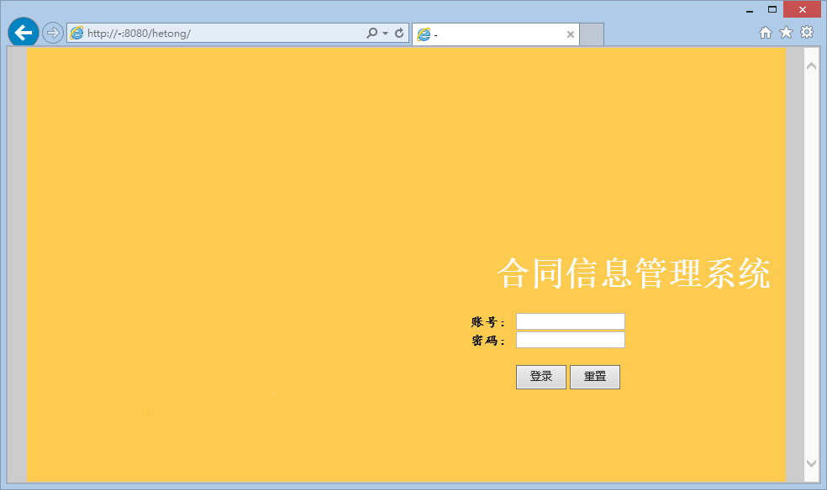

2.4 Application
1. Requirement Function : login
(1) Functional description
Login, input user name and password.
(2) Running screenshot
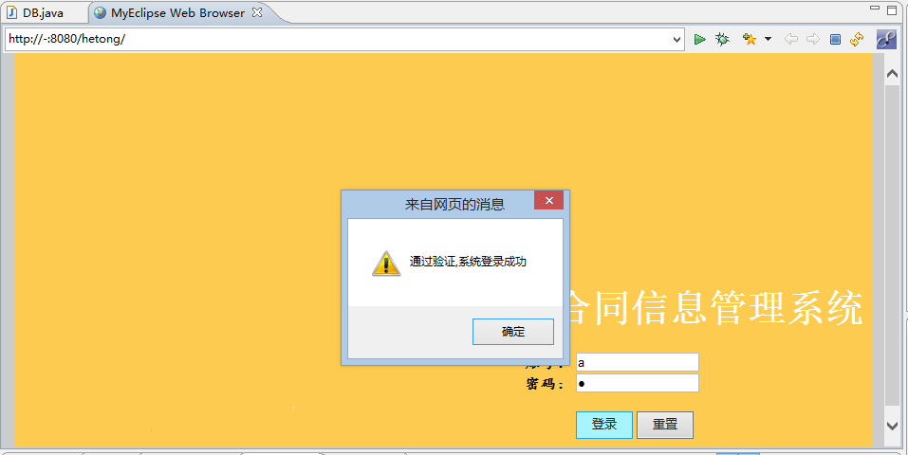

(3) Development idea and core code
package com.service;

public class loginService
{
public String login(String userName,String userPw,int userType)
{
System.out.println("userType"+userType);
try
{
Thread.sleep(700);
} catch (InterruptedException e)
{
// TODO Auto-generated catch block
e.printStackTrace();
}

String result="no";

if(userType==0)//系统管理员登陆
{
String sql="select * from t_admin where userName=? and userPw=?";
Object[] params={userName,userPw};
DB mydb=new DB();
mydb.doPstm(sql, params);
try
{
ResultSet rs=mydb.getRs();
boolean mark=(rs==null||!rs.next()?false:true);
if(mark==false)
{
result="no";
}
else
{
result="yes";
TAdmin admin=new TAdmin();
admin.setUserId(rs.getInt("userId"));
admin.setUserName(rs.getString("userName"));
admin.setUserPw(rs.getString("userPw"));
WebContext ctx = WebContextFactory.get();
HttpSession session=ctx.getSession();
session.setAttribute("userType", 0);
session.setAttribute("admin", admin);
}
rs.close();
}
catch (SQLException e)
{
System.out.println("登录失败！");
e.printStackTrace();
}
finally
{
mydb.closed();
}

}

if(userType==1)
{
}
if(userType==2)
{
}
return result;
}

public String adminPwEdit(String userPwNew)
{
System.out.println("DDDD");
try
{
Thread.sleep(700);
}
catch (InterruptedException e)
{
e.printStackTrace();
}
WebContext ctx = WebContextFactory.get();
HttpSession session=ctx.getSession();
TAdmin admin=(TAdmin)session.getAttribute("admin");

String sql="update t_admin set userPw=? where userId=?";
Object[] params={userPwNew,admin.getUserId()};
DB mydb=new DB();
mydb.doPstm(sql, params);

return "yes";
}

public List hetongSelect()
{
try
{
Thread.sleep(700);
}
catch (InterruptedException e)
{
e.printStackTrace();
}
List hetongList=new ArrayList();
String sql="select * from t_hetong where zt ='正常'";
Object[] params={};
DB mydb=new DB();
try
{
mydb.doPstm(sql, params);
ResultSet rs=mydb.getRs();
while(rs.next())
{
Thetong hetong=new Thetong();

hetong.setId(rs.getInt("id"));
hetong.setMingcheng(rs.getString("mingcheng"));
hetong.setJiafangfuzeren(rs.getString("jiafangfuzeren"));
hetong.setYifangfuzeren(rs.getString("yifangfuzeren"));

hetong.setKaishishijian(rs.getString("kaishishijian"));
hetong.setJieshushijian(rs.getString("jieshushijian"));
hetong.setJine(rs.getInt("jine"));
hetong.setBeizhu(rs.getString("beizhu"));

hetong.setZt(rs.getString("zt"));

hetongList.add(hetong);
}
rs.close();
}
catch(Exception e)
{
e.printStackTrace();
}
mydb.closed();
return hetongList;
}
}

2. Requirement Function : contract manage
(1) Functional description
Show all the messages of all the contracts. Read data from db_hetong database.
(2) Running screenshot
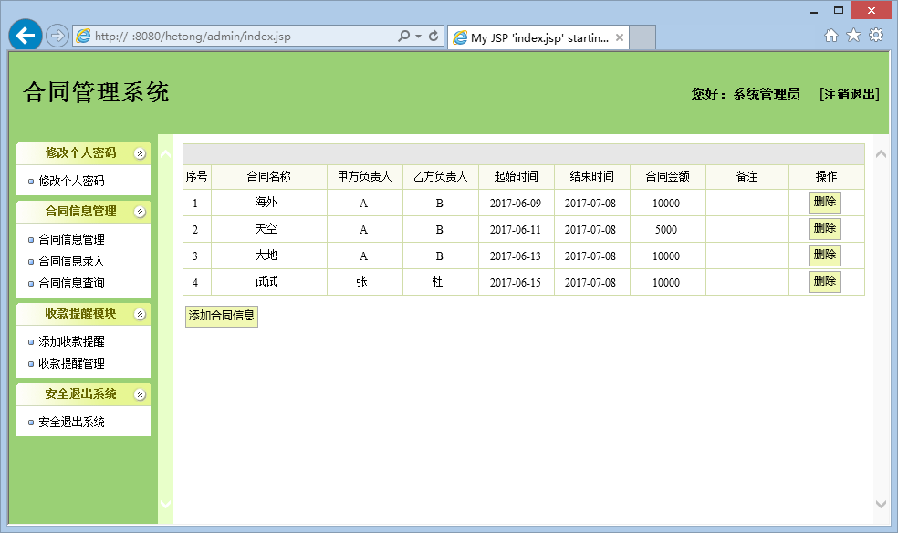
(3) Development idea and core code
public void hetongMana(HttpServletRequest req,HttpServletResponse res) throws ServletException, IOException
{
List hetongList=new ArrayList();
String sql="select * from t_hetong where zt ='正常'";
Object[] params={};
DB mydb=new DB();
try
{
mydb.doPstm(sql, params);
ResultSet rs=mydb.getRs();
while(rs.next())
{
Thetong hetong=new Thetong();

hetong.setId(rs.getInt("id"));
hetong.setMingcheng(rs.getString("mingcheng"));
hetong.setJiafangfuzeren(rs.getString("jiafangfuzeren"));
hetong.setYifangfuzeren(rs.getString("yifangfuzeren"));

hetong.setKaishishijian(rs.getString("kaishishijian"));
hetong.setJieshushijian(rs.getString("jieshushijian"));
hetong.setJine(rs.getInt("jine"));
hetong.setBeizhu(rs.getString("beizhu"));

hetong.setZt(rs.getString("zt"));

hetongList.add(hetong);
}
rs.close();
}
catch(Exception e)
{
e.printStackTrace();
}
mydb.closed();

req.setAttribute("hetongList", hetongList);
req.getRequestDispatcher("admin/hetong/hetongMana.jsp").forward(req, res);
}

public void hetongRes(HttpServletRequest req,HttpServletResponse res) throws ServletException, IOException
{
System.out.println(req.getParameter("mingcheng").trim()+"HH");

List hetongList=new ArrayList();
String sql="select * from t_hetong where mingcheng like '%"+req.getParameter("mingcheng")+"%'";
Object[] params={};
DB mydb=new DB();
try
{
mydb.doPstm(sql, params);
ResultSet rs=mydb.getRs();
while(rs.next())
{
Thetong hetong=new Thetong();

hetong.setId(rs.getInt("id"));
hetong.setMingcheng(rs.getString("mingcheng"));
hetong.setJiafangfuzeren(rs.getString("jiafangfuzeren"));
hetong.setYifangfuzeren(rs.getString("yifangfuzeren"));

hetong.setKaishishijian(rs.getString("kaishishijian"));
hetong.setJieshushijian(rs.getString("jieshushijian"));
hetong.setJine(rs.getInt("jine"));
hetong.setBeizhu(rs.getString("beizhu"));

hetong.setZt(rs.getString("zt"));

hetongList.add(hetong);
}
rs.close();
}
catch(Exception e)
{
e.printStackTrace();
}
mydb.closed();

req.setAttribute("hetongList", hetongList);
req.getRequestDispatcher("admin/hetong/hetongMana.jsp").forward(req, res);
}

3. Requirement Function : add contract
(1) Functional description
Input follows the remind, save to db_hetong database.
(2) Running screenshot
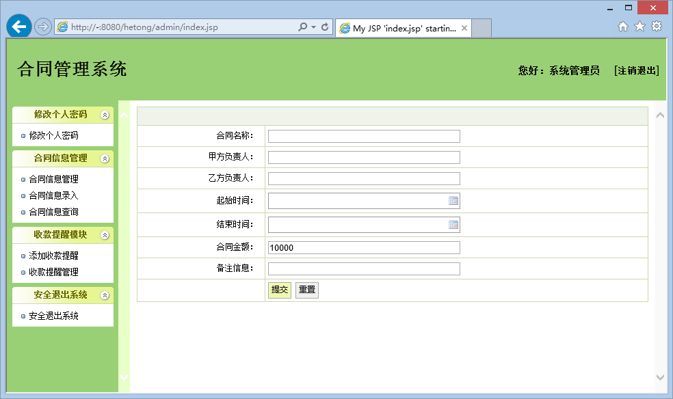
(3) Development idea and core code
public void hetongAdd(HttpServletRequest req,HttpServletResponse res)
{
String mingcheng=req.getParameter("mingcheng");
String jiafangfuzeren=req.getParameter("jiafangfuzeren");
String yifangfuzeren=req.getParameter("yifangfuzeren");
String kaishishijian=req.getParameter("kaishishijian");

String jieshushijian=req.getParameter("jieshushijian");
int jine=Integer.parseInt(req.getParameter("jine"));
String beizhu=req.getParameter("beizhu");
String zt="正常";

String sql="insert into t_hetong values(?,?,?,?,?,?,?,?)";
Object[] params={mingcheng,jiafangfuzeren,yifangfuzeren,kaishishijian,jieshushijian,jine,beizhu,zt};
DB mydb=new DB();
mydb.doPstm(sql, params);
mydb.closed();

req.setAttribute("msg", "信息添加完毕");
String targetURL = "/common/msg.jsp";
dispatch(targetURL, req, res);
}

4. Requirement Function : contract query
(1) Functional description
Input key words, select from db_hetong database.
(2) Running screenshot
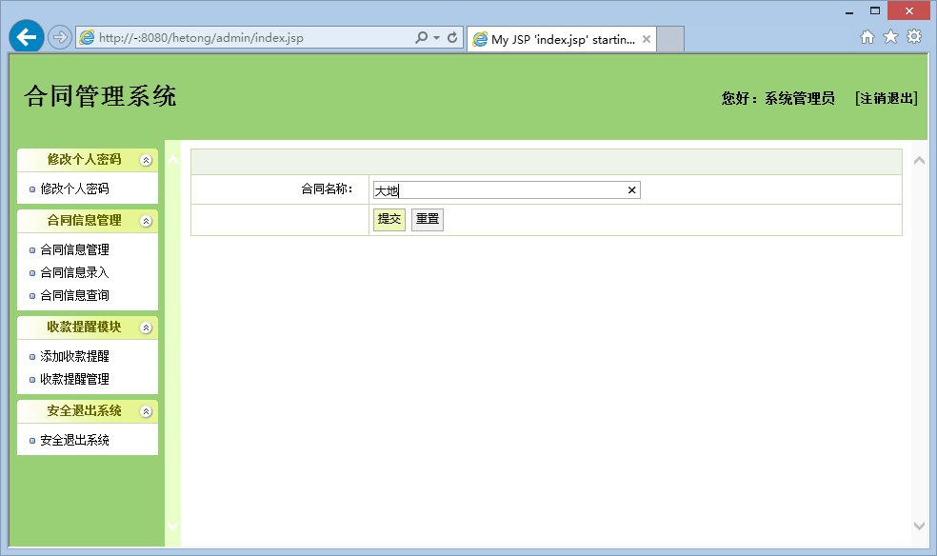
(3) Development idea and core code
public static Thetong get_hetong(int id)
{
Thetong hetong=new Thetong();
String sql="select * from t_hetong where id=?";
Object[] params={id};
DB mydb=new DB();
try
{
mydb.doPstm(sql, params);
ResultSet rs=mydb.getRs();
while(rs.next())
{
hetong.setId(rs.getInt("id"));
hetong.setMingcheng(rs.getString("mingcheng"));
hetong.setJiafangfuzeren(rs.getString("jiafangfuzeren"));
hetong.setYifangfuzeren(rs.getString("yifangfuzeren"));

hetong.setKaishishijian(rs.getString("kaishishijian"));
hetong.setJieshushijian(rs.getString("jieshushijian"));
hetong.setJine(rs.getInt("jine"));
hetong.setBeizhu(rs.getString("beizhu"));

hetong.setZt(rs.getString("zt"));
}
rs.close();
}
catch(Exception e)
{
e.printStackTrace();
}
mydb.closed();

return hetong;
}

5.Requirement Function : contract delete
(1) Functional description
Delete contract.
(2) Running screenshot
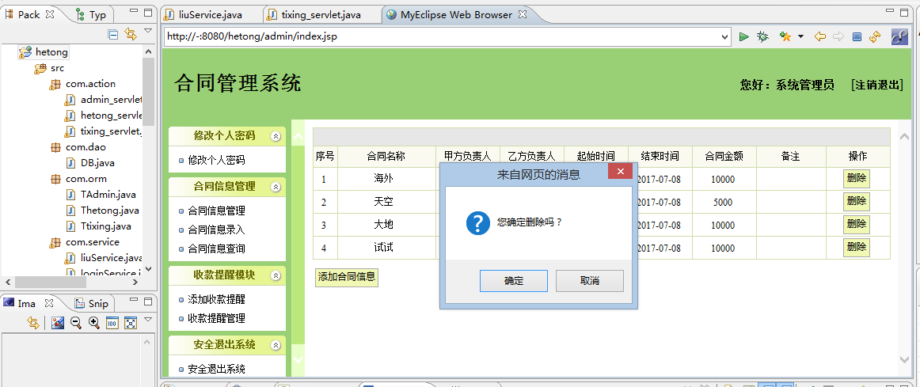

(3) Development idea and core code
public void hetongDel(HttpServletRequest req,HttpServletResponse res)
{
int id=Integer.parseInt(req.getParameter("id"));

String sql="update t_hetong set zt='删除' where id=?";
Object[] params={id};
DB mydb=new DB();
mydb.doPstm(sql, params);
mydb.closed();

req.setAttribute("msg", "信息删除完毕");
String targetURL = "/common/msg.jsp";
dispatch(targetURL, req, res);
}

6.Requirement Function : contract proceeds remind
(1) Functional description
Add remind and manage remind and delete remind.
(2) Running screenshot
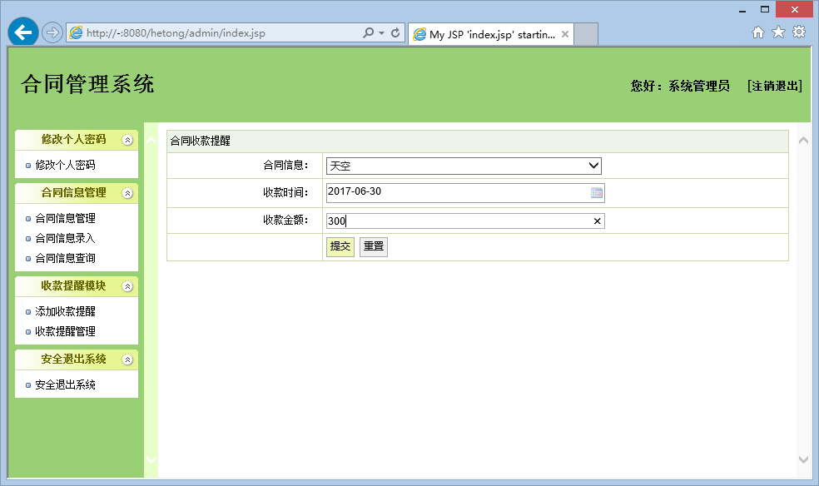

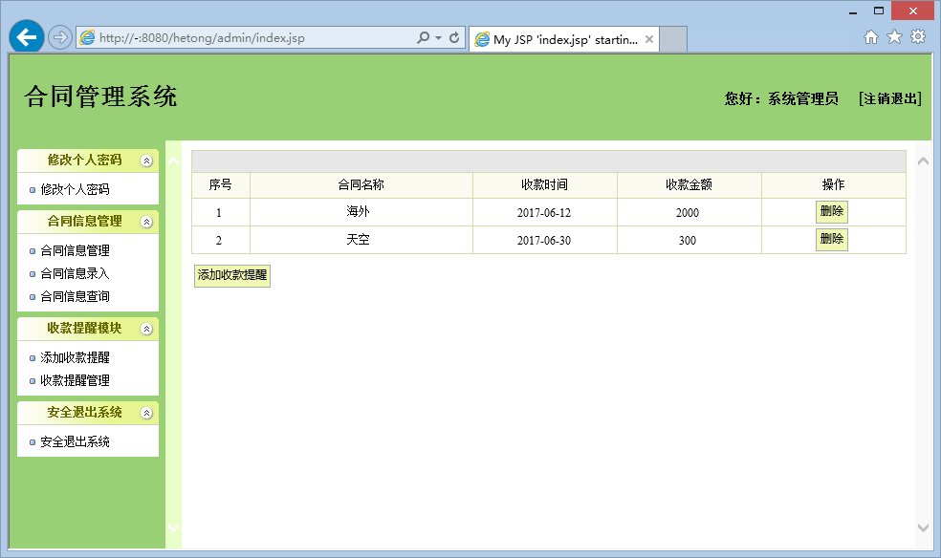

(3) Development idea and core code
public void tixingAdd(HttpServletRequest req,HttpServletResponse res)
{
int hetong_id=Integer.parseInt(req.getParameter("hetong_id"));
String shoukuanshijian=req.getParameter("shoukuanshijian");
int shoukuanjine=Integer.parseInt(req.getParameter("shoukuanjine"));

String sql="insert into t_tixing values(?,?,?)";
Object[] params={hetong_id,shoukuanshijian,shoukuanjine};
DB mydb=new DB();
mydb.doPstm(sql, params);
mydb.closed();

req.setAttribute("msg", "信息添加完毕");
String targetURL = "/common/msg.jsp";
dispatch(targetURL, req, res);
}

public void tixingMana(HttpServletRequest req,HttpServletResponse res) throws ServletException, IOException
{
List tixingList=new ArrayList();
String sql="select * from t_tixing order by hetong_id";
Object[] params={};
DB mydb=new DB();
try
{
mydb.doPstm(sql, params);
ResultSet rs=mydb.getRs();
while(rs.next())
{
Ttixing tixing=new Ttixing();

tixing.setId(rs.getInt("id"));
tixing.setHetong_id(rs.getInt("hetong_id"));
tixing.setShoukuanshijian(rs.getString("shoukuanshijian"));
tixing.setShoukuanjine(rs.getInt("shoukuanjine"));

tixing.setHetong(liuService.get_hetong(rs.getInt("hetong_id")));

tixingList.add(tixing);
}
rs.close();
}
catch(Exception e)
{
e.printStackTrace();
}
mydb.closed();

req.setAttribute("tixingList", tixingList);
req.getRequestDispatcher("admin/tixing/tixingMana.jsp").forward(req, res);
}

public void tixingDel(HttpServletRequest req,HttpServletResponse res)
{
int id=Integer.parseInt(req.getParameter("id"));

String sql="delete from t_tixing where id=?";
Object[] params={id};
DB mydb=new DB();
mydb.doPstm(sql, params);
mydb.closed();

req.setAttribute("msg", "信息删除完毕");
String targetURL = "/common/msg.jsp";
dispatch(targetURL, req, res);
}

2.5 Deliverables
Processes(Stages) | Deliverables | Deliver or not（√） | Remarks
Project start | Project Start Report | ✔
Project planning | Project Planning Report | ✔
Requirement analysis | Requirement Specifications（SRS） | ✔
System design | System Design Specifications（SD） | ✔
Coding implementation and test | Project Source Code | ✔
Coding implementation and test | Project user’s manual | ✔
Acceptance and close | Project Closure Summary Report | ✔

3. Project Work Summary

3.1 Document work summary
Name | Process | Document | Pages
 | Initialization | Project Start Report | 7
 | Plan | Project Planning(optional) | 6
 | RA | Requirement Specification(optional) | 21
 | System Design | System Design(optional) | 20
 | Implement | User Manual | 9
 | Accepting | Project Acceptance report | /
 | Accepting | Project Closure Summary Report | 22
Total |  |  | 85

